Repeated sprint training in semi-professional soccer players: manipulating within- and between-set rest intervals

Abstract:

Recent meta-analyses of repeated sprint training have advanced our understanding of this training strategy, yet the impact of manipulating rest intervals is relatively unexplored. We therefore explored the effects of a twice-weekly, six-week repeated-sprint protocol that was time and volume-matched but with varying within- and between-set rest intervals on fitness outcomes in semi-professional male soccer players. Twenty-three players (Tier 2) were randomly allocated to Group 1 (10 seconds within-set and 80-second between-set rest; n = 12) or Group 2 (20 seconds within-set and 40 to 54 seconds between-set rest; n = 11). Both groups continued soccer-specific, gym-based training and matches. Training intensity (differential ratings of perceived exertion; dRPE) and fitness changes (10 m, 20 m, 40 m sprint times, maximum velocity, countermovement jump height, maximal aerobic speed) were assessed, and effects interpreted using statistical significance and equivalence testing. For training intensity, the fixed effects of group, training mode, and dRPE were statistically significant yet practically equivalent as the 90% confidence intervals were within the equivalence region of 8 AU. For the fitness outcomes, between-group effects were not statistically significant and practically equivalent across all fitness outcomes except maximum velocity. Within both groups, all fitness outcomes improved significantly yet only the improvements in maximum velocity were large enough to be considered practically important as the 90% confidence intervals were outside the equivalence region. These findings suggest when sprint volume is equated, practitioners may have flexibility in adjusting within- and between-set rest intervals without compromising fitness adaptations in semi-professional male soccer players.

Keywords: Physical fitness, Training intensity, RPE, Soccer, Equivalence testing

Introduction
Semi-professional soccer players cover ~10 km per match, with high-speed running and sprinting constituting ~5% and ~3%, respectively, of the total distance (Castillo-Rodríguez et al., 2020). Semi-professional players also perform repeated high-intensity accelerations (1.78 ± 0.38 per minute, at > (2 m.s⁻²)) and decelerations (1.80 ± 0.40 per minute, at < (- 2 m.s⁻²)) per match (Ortigosa-Melero et al., 2022). While the frequency of high-intensity actions in soccer is relatively low, importance is seen via 83% of goals being preceded by short sprints or jumps (Faude et al., 2012).
Along with match demands, players also need to manage congested match schedules, with the majority of training time dedicated to technical and tactical training. As such, prescribing multiple training modalities can be challenging for practitioners due to the limited time available and constraints on players’ workload (Freitas et al., 2021; Turner & Stewart, 2014). In light of these scheduling constraints, repeated sprint training (i.e., maximal-effort, short-duration sprints (≤10 sec) interspersed with brief recovery periods (≤60 sec)) is a time-efficient strategy for improving multiple fitness components relevant to soccer performance (Girard et al., 2011; Taylor et al., 2015; Thurlow, Huynh, et al., 2023). Recent meta-analyses (Thurlow, Huynh, et al., 2023; Thurlow, Weakley, et al., 2023) show the multi-component benefits of short-term (i.e., two to five weeks) repeated sprint training with training-induced improvements in linear sprint speed, acceleration, change of direction ability, explosive leg power, and high-intensity intermittent running performance - all of which are integral to soccer (Negra et al., 2023). Such improvements suggest repeated sprint training could replace isolated training modalities (e.g., distinct speed, endurance, and power sessions), thus maximising training efficiency (Freitas et al., 2021; Turner & Stewart, 2014). Coaches can, therefore, leverage repeated sprint training to develop fitness qualities in a single, streamlined protocol.
When prescribing repeated sprint training, manipulating the structure of the training session can alter performance outcomes and responses to training (Laursen & Buchheit, 2019). One such method of structuring training sessions is varying the rest intervals (Hill-Haas et al., 2007; Jukic et al., 2020), yet the effects of different within- and between-set rest intervals are not well-established (Thurlow, Huynh, et al., 2023). Recent meta-analyses have shown a 20-sec within-set rest for a sprint distance of 30 m or 40 m as the most common repeated sprint training prescription, resulting in a work:rest ratio of roughly (1:4), but there is little consensus regarding the prescription of a particular between-set rest time in relation to repeated sprint training adaptations (Thurlow, Huynh, et al., 2023; Thurlow, Weakley, et al., 2023). Most studies investigating the effects of varying within-sprint rest have chosen broader work:rest ratios (1:1 vs 1:6) or (1:3 vs 1:6) but with no standardised prescription for between-sprint rest interval as reported in the above-mentioned meta-analyses (Iaia et al., 2017; Saraslanidis et al., 2011). Further, these studies had a low volume of repetitions, fit but not well-trained participants, youth populations, sprint-based fitness tests, and failed to match total sprint time and volume between groups.
To our knowledge, the potential impact of varied within and between-set rest intervals has yet to be thoroughly examined. Our study, therefore, aimed to examine the effects of two different repeated-sprint protocols that were time and volume-matched but differed in within- and between-set rest intervals on fitness measures relevant to soccer performance in male semi-professional players.
Methods
Participants
A soccer team (n = 30 players) that competes in the Scottish Lowland Semi-Professional League and the top league of British Universities and Colleges Sport was invited to participate in this study. The justification for our sample size is that we had the entire population, i.e., the entire first-team squad were invited to participate (Lakens, 2022). Inclusion criteria required participants to be injury-free, have a soccer training history of three years and have trained consistently for at least 6 months before study entry. Upon initial assessment, twenty-six participants satisfied the inclusion criteria (n = 26, Age: 22.8 ± 4.2 years, Weight: 75.9 ± 7.5 kg, Height: 181.1 ± 7.2 cm) (mean ± SD); however, those who could not begin the intervention at the start date due to unavailability (n = 3) were excluded. Participants were informed of the study procedures using participant information sheets and signed an electronic informed consent form before initiating this study. The University of Edinburgh Institutional Review Board approved the study protocol. The players are classified as Tier 2 on the McKay classification framework (McKay et al., 2022), and Figure 1 shows the participant study flow.

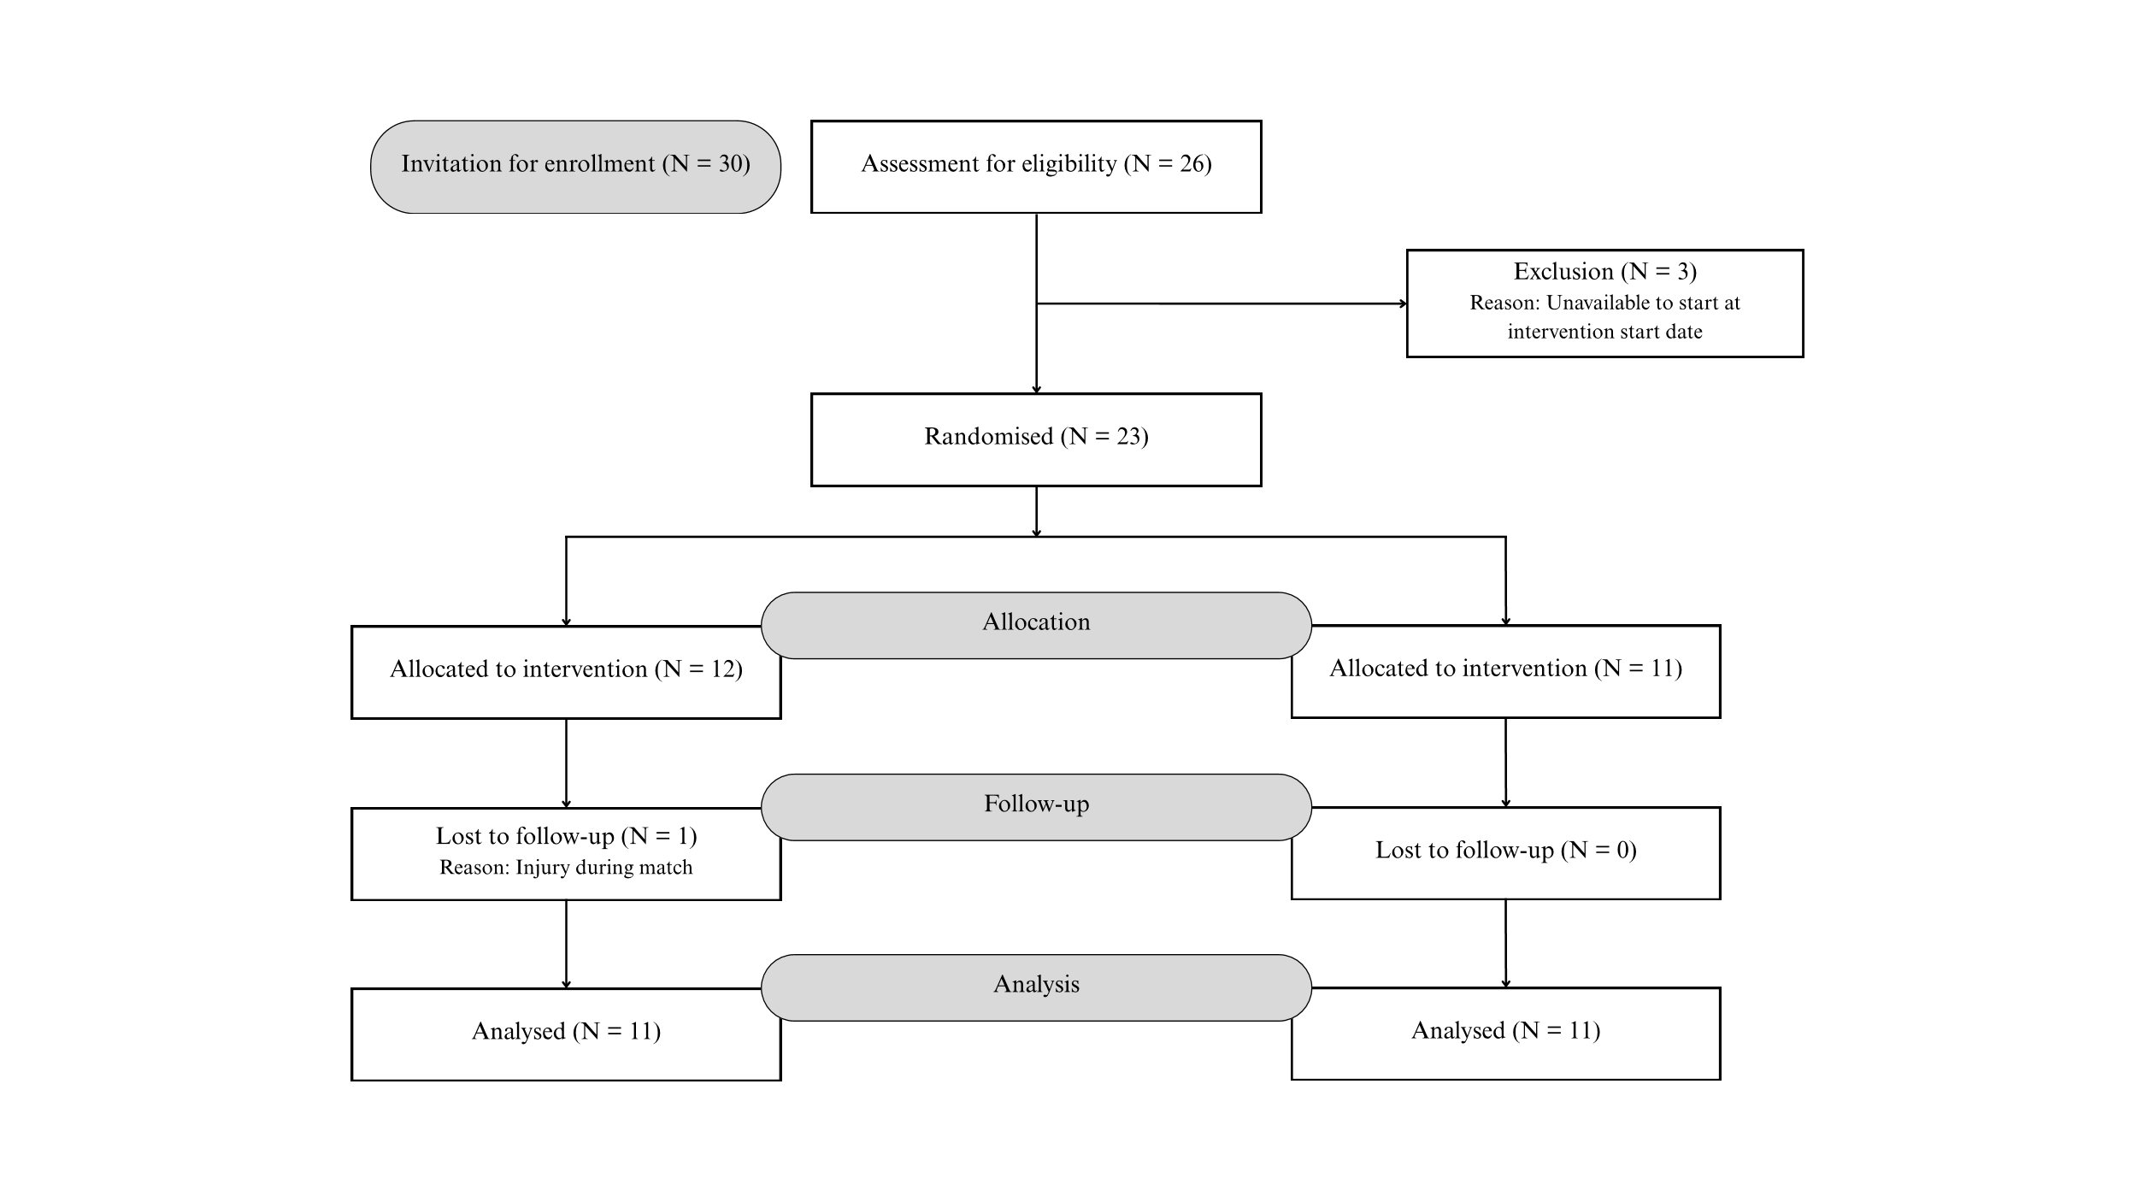
Figure 1. Participant flow chart

Experimental Approach to the Problem
A parallel group design examined the effects of two six-week repeated sprint training protocols with different within- and between-set rest intervals on fitness outcomes relevant to soccer. Following baseline testing, participants were randomly allocated to either a (10-sec within-set and 80-sec between-set rest, Group 1 [n = 12]) or (20-sec within-set and 40 to 54-sec between-set rest, Group 2 [n = 11]) using a minimisation approach with randomisation being carried out by one of the study authors who was not involved in baseline testing. Minimisation aims to achieve a balance between groups across several variables, even with small sample sizes (Altman & Bland, 2005) and the variables chosen were age, 10-m sprint time, maximum velocity, counter-movement jump height and maximal aerobic speed (Table 1). Minimisation was performed using a custom-made spreadsheet (Hopkins, 2010). Participants were already familiar with the fitness tests through their regular physical preparation program, so further test familiarisation was unnecessary.
On the first day of testing, body mass, stature, counter-movement jump height, maximum velocity, and linear sprint time tests were measured with the maximal aerobic speed measured on the second day when the investigator also explained the CR100 scale (centiMax® scale (CR100)) (Borg et al., 2010). The study was conducted during the soccer pre-season and all fitness tests were scheduled at the same time of day (5:00 – 9:00 PM) under similar environmental conditions (18.2 °C WBGT, 7.3 km/h Wind Speed, 55.2% Relative Humidity) (Kestrel 5400 (WBGT, HST, and WM), Kestrel Instruments) on the same artificial turf soccer pitch. During the study, the first author of the study, who is a certified strength and conditioning specialist with the National Strength and Conditioning Association (NSCA), provided both groups with a standardised gym-based training program, and both groups maintained their regular soccer-specific training.
Table 1. Participant Baseline Characteristics (Mean ± SD)
Characteristic | Group 1  n = 12 | Group 2  n = 11
Age (years) | 23.3 ± 4.4 | 22.3 ± 4.1
10m Sprint Time (s) | 1.81 ± 0.08 | 1.80 ± 0.12
Maximal Velocity (m/s) | 8.69 ± 0.48 | 8.78 ± 0.42
Counter-movement Jump Height (cm) | 39.5 ± 3.9 | 39.5 ± 3.9
Maximal Aerobic Speed (m/s) | 4.10 ± 0.23 | 4.09 ± 0.2

Intervention
Participants performed soccer-specific training twice a week, comprising 15-min of technical drills, 15-min of physical conditioning drills, 30-min of tactical/possession drills, and 30-min of various-sided games (intensive themed session on Monday and extensive themed session on Thursday), gym-based training twice weekly on self-selected days, and played matches on weekends. The weekday soccer training sessions lasted ~90 minutes and included warm-up, physical conditioning, technical/tactical skills development, and active recovery strategies. During the 6-week intervention period, the regular physical conditioning drills performed on Mondays and Thursdays were replaced by the repeated sprint training protocols, ensuring 72 hours recovery between sessions. In contrast, the rest of the weekly schedule routine was kept the same as before the study so that overall training exposure was identical between the two experimental groups apart from the prescribed repeated sprint training intervention. When a participant was unable to attend a session, the session was rescheduled with the objective of completing it within the same week. Overall, 10 individual sessions, including four repeated sprint training-based sessions, were rearranged across the intervention.
The two repeated-sprint training protocols (Table 2) were time and volume matched to ensure the ~4-min overall recovery periods and sprint volume stayed consistent across the two groups (Thurlow, Huynh, et al., 2023; Thurlow, Weakley, et al., 2023; Weakley, Pérez Castilla, et al., 2023). Participants were supervised through a 10-minute dynamic warm-up using the “Raise, Activate, Mobilise, Potentiate” protocol (Haff & Triplett, 2015), which included ~3 minutes of continuous running (13 Shuttles, 50 meters, ~13 km.h⁻¹) (Shushan et al., 2024) and 5 minutes of lower-limb dynamic exercises (e.g., overhead walk on toes, walking hamstring stretches, walking linear and lateral lunges, walking hip openers, high knees, etc.). Following this, participants performed two progressive sprints of 35 m at 70% and 90% of their perceived maximal effort (Marcote-Pequeño et al., 2019) as repeated sprint training specific dynamic warm-up and potentiation.
Participants were encouraged by the first author of this study to exert maximum effort for each sprint across training sessions. All testing and training sessions occurred on artificial turf and were supervised by the first author. Participants were instructed to maintain a standard diet throughout the intervention period and avoid alcohol and caffeine in the 12 hours preceding testing.
Table 2. Repeated Sprint Training Protocols
Fitness Tests
Height and body mass were measured using a portable stadiometer (Seca Alpha model 213, Hamburg, Germany) and weighing scale (Seca 877 scales, Hamburg, Germany). All fitness tests were conducted within 10 days pre and post intervention and administered by the first author of this study who not blinded to group allocation. Sprint times were measured using Electronic Timing Gates (Microgate srl, Bolzano, Italy) at 10 m splits. Participants were instructed to start with their dominant foot in a 2-point crouching staggered position on a point 0.5 m behind the timing gates before each effort, with a voluntary start of the sprint (Weakley, McCosker, et al., 2023). Timing gates were placed 0.75 m above the ground to ensure they captured trunk movement and avoided false signals through limb motion, between-trial recovery time was a passive three minutes, and the fastest sprint was retained for analysis. Maximum velocity was assessed using 10-Hz Global Positioning System (Polar Team Pro, Polar Electro, Kempele, Finland) (Roe et al., 2017). Assessing short sprint performance using timing gates and 10 Hz has consistently shown good reliability (Coefficient of Variation (CV) = 1 to 3%) (Weakley, McCosker, et al., 2023). Counter-movement jump height was measured by a counter-movement jump, with hands placed on the hips, via a dual force plate system (ForceDecks V2, Vald Performance, Brisbane, QLD, Australia). The impulse-momentum approach was used to calculate jump height while keeping time-to-take-off and countermovement depth similar over multiple attempts. The best of three trials was recorded. Assessing jump height via force plates has consistently shown good reliability (CV = 3.1 to 3.5%) (Collings et al., 2024). Finally, maximal aerobic speed was assessed via a 1600 m distance trial, with the speed assessed as per Bellenger et al. (2015). Set distance trials (1600 m to 2200 m) are reliable (CV = 1 – 3%) for calculating maximal aerobic speed (Bellenger et al., 2015).
Training Monitoring
All training sessions were monitored by differential ratings of perceived exertion (dRPE) (breathlessness [dRPE-B], leg muscle exertion [dRPE-L]), measured using the CR100 scale (Borg & Kaijser, 2006), collected at the end of every training modality (repeated-sprint training, soccer-specific training, gym-based training, and weekly matches), and recorded via custom-made online forms (McLaren et al., 2016).
Statistical Analysis
Data were imported and visualised using tidyverse, sjPlot, easystats, ggrain, and ggpubr packages (Allen et al., 2021; Kassambara, 2023, 2023; Lüdecke, 2024; Lüdecke et al., 2022). The visdat package (Tierney, 2017) confirmed no missing training or fitness test data. Training intensity (dRPE) was explored with the lme4 package (Bates et al., 2015) and model assumptions verified via the performance package (Lüdecke et al., 2022). We compared two models, 1) fixed effect of group (group one, group two), training mode (repeated-sprint training, matches, soccer training, gym-based training), dRPE measure (dRPE-L, dRPE-B), and session number (one to twelve, modelled as a continuous variable), and 2) the same fixed effects but with nested random effects (player/session). These models were essentially equivalent (Burnham et al., 2011), and ICC of only 0.016 and a between-player standard deviation of 0.6 (95%CI 0.0, 1.0) AU shows that player explained little heterogeneity in training intensity, so the mixed model was not required.
Analysis of covariance (ANCOVA), via the stats package, compared the between-group post-pre changes in fitness tests and body mass with pre-test as a covariate to control for any imbalances between the groups at baseline that can occur even after minimisation (Senn, 2006). In the presence of heteroskedasticity, standard errors were adjusted using "CR2" small sample correction variance estimators ( Pustejovsky & Tipton, 2018) using the clubSandwich package ( Pustejovsky, 2024).
We used simple effect sizes over standardised effect sizes as these are independent of variance and scale the original units which maximises practical context (Baguley, 2009). Effects are interpreted via traditional null hypothesis significance testing (i.e., p < 0.05) and by equivalence testing. Equivalence testing can be determined via visual inspection of 90% confidence intervals in relation to a region of practical equivalence (Lakens et al., 2018) with effects declared as either practically equivalent (confidence interval completely within the equivalence region), not practically equivalent (confidence interval overlaps the equivalence region), or practically important (confidence interval completely outside the equivalence region) (Ganju & Rom, 2017; Lakens et al., 2018). For the between-group comparison of training intensity, we set our region of practice equivalence as 8 AU (Wright et al., 2020). To determine equivalence in fitness outcomes, 90% confidence intervals for within-group effects and ANCOVA-adjusted between-group differences, our regions of practical equivalence were: sprint times (10m = 0.114 s, 20m = 0.162 s, 40m = 0.258 s) derived from linear regression modelling (R² = 0.992) based on Datson et al. (2022); maximum velocity (0.2 m·s⁻¹) (Kyprianou et al., 2022); countermovement jump (2.8 cm) (Datson et al., 2022); and maximal aerobic speed using minimal detectable change from a 2% coefficient of variation (Bellenger et al., 2015). We acknowledge perceived change scores are context dependent (Datson et al., 2022) and that ideally, measurement error is not used to infer important practical differences (De Vet & Terwee, 2010). However, our sport shares similarities with Datson et al. (2022) as it is team-based and the use of expert opinion can maximise the practical context of findings (Cook et al., 2018) and as such, provides a critical counterpoint to an interpretation solely on statistical grounds (Datson et al., 2022). All visualisations and analyses were performed in R (version 4.4.3, R Foundation for Statistical Computing).
Results
Twenty-two of the twenty-three participants completed the interventions with 100% attendance (42/42 sessions). One participant withdrew due to a contact injury during a match in the third week of the study, and their data was withdrawn from the study (Figure 1). No significant within-participant and between-group bodymass differences were observed post-intervention.
Training intensity (dRPE) data are presented in Figure 2. With the exception of session, all between-group fixed effects were statistically significant yet practically equivalent as the 90% confidence intervals sat completely within the equivalence region (Figure 3). Pre- and post-test data for all outcome measures are shown in Figure 4 and the influence of pre-test scores on the change score (post-test – pre-test) is shown in Figure 5. The between-group analysis indicated no statistically significant differences in fitness outcomes, and the groups were considered practically equivalent across all fitness outcomes except for maximum velocity (Figure 6). Conversely, within-group changes were statistically significant for all outcomes in both groups and the improvement in maximum velocity was large enough to be considered practically important as the 90% confidence intervals sat completely outside the equivalence region.
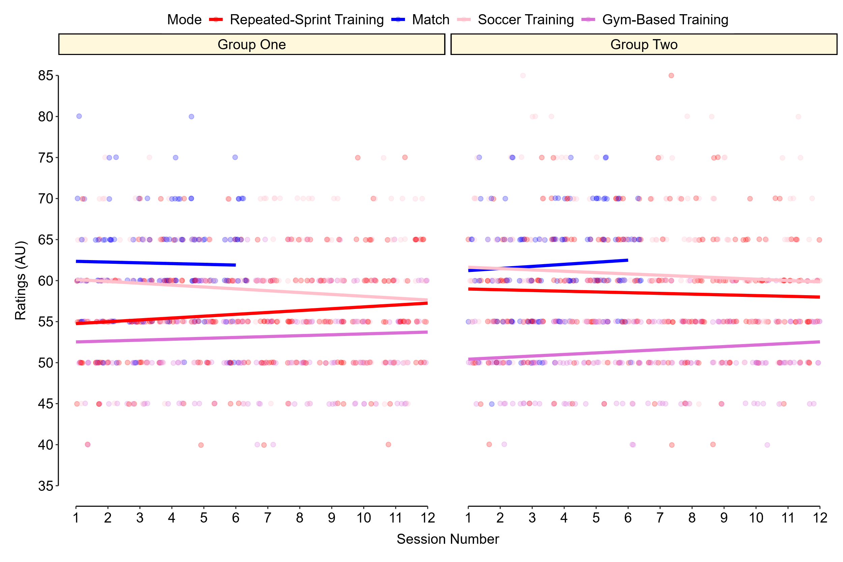
Figure 2. Training Intensity (dRPE) coloured by training mode across the study

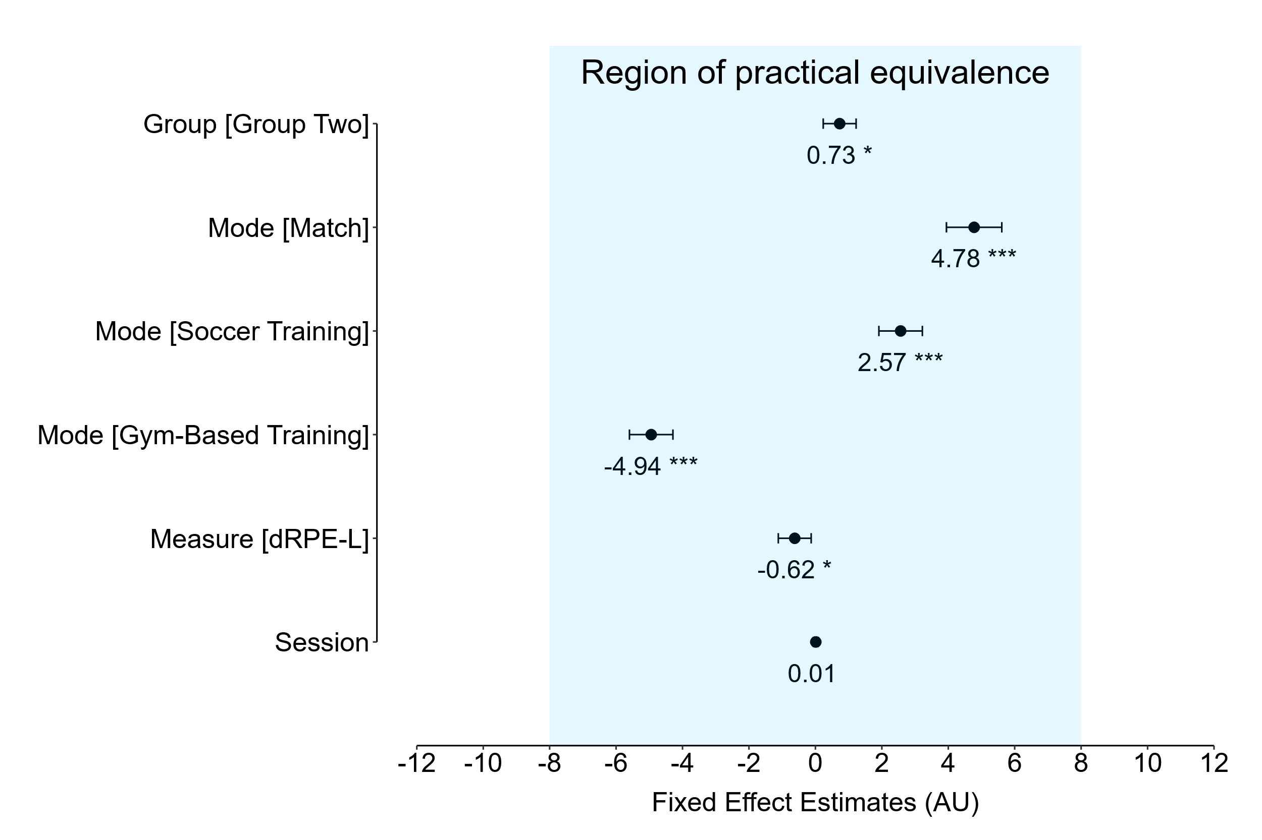
Figure 3. Fixed effect estimates (group, training mode, dRPE measure, and session number), along with 90% confidence intervals (* p < 0.05, ** p < 0.01, *** p < 0.001). Group one, repeated-sprint training, dRPE-B, and session one were the reference categories.
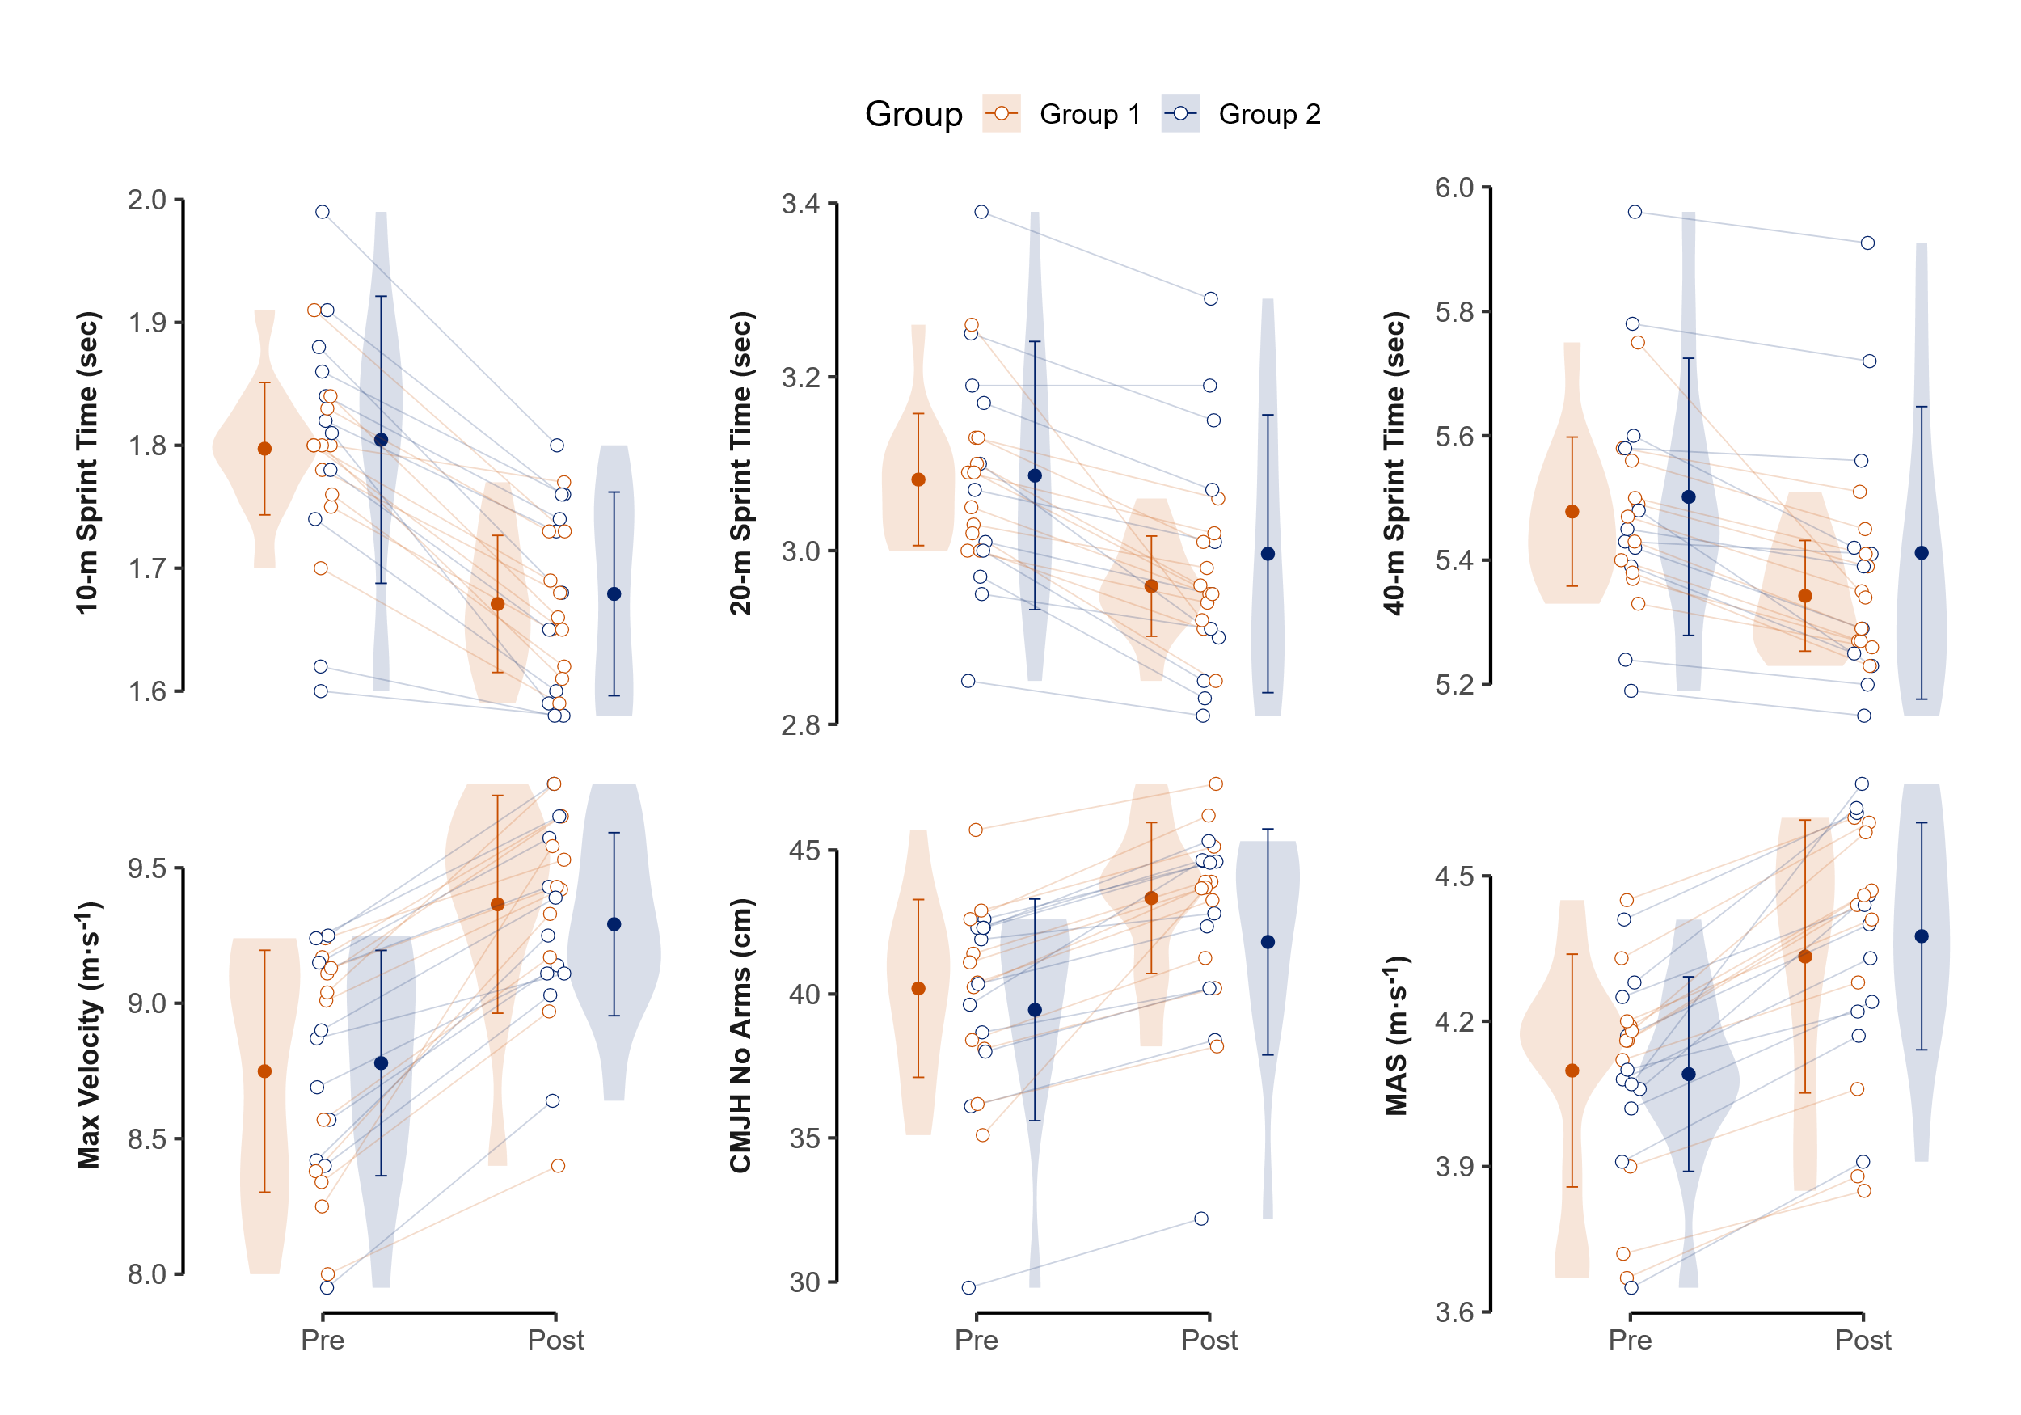
Figure 4. Pre- and post-test scores for all outcome measures

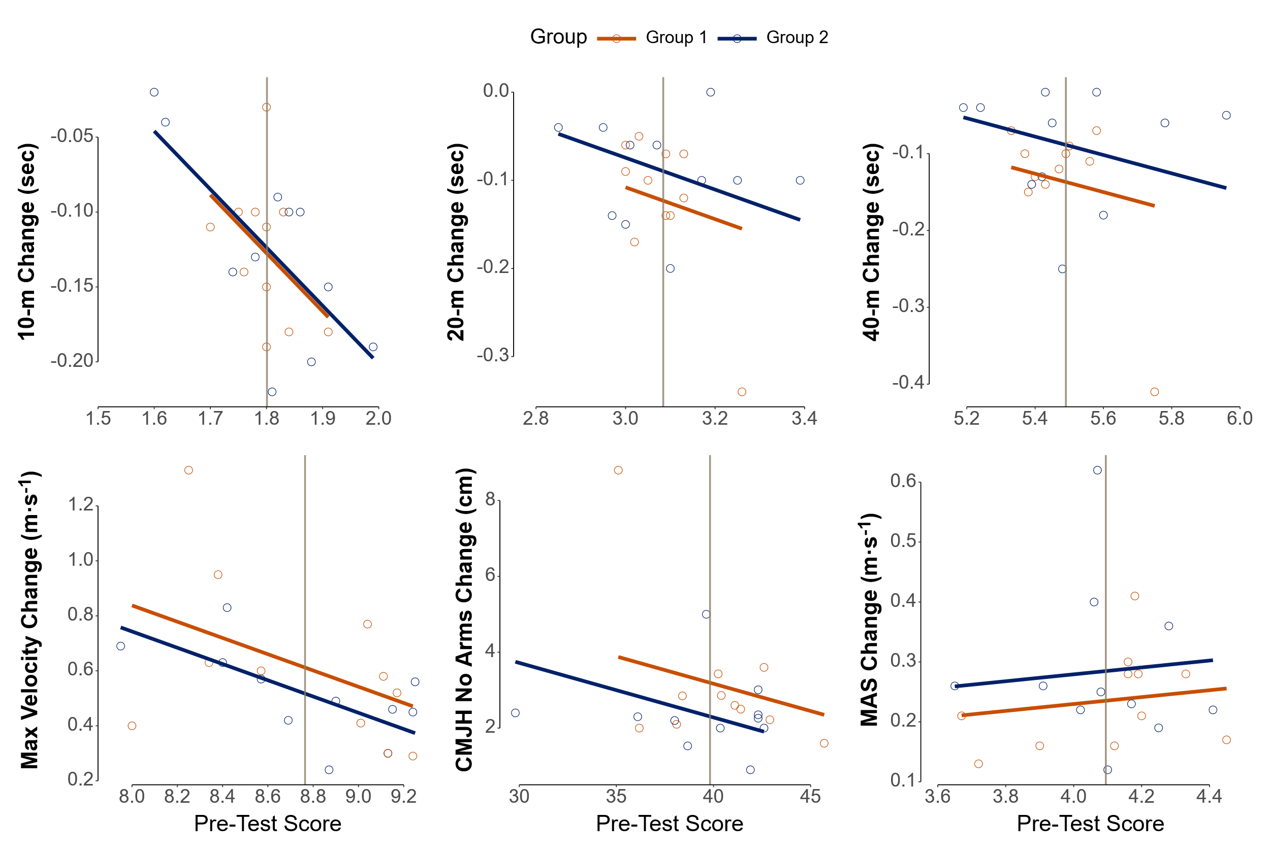
Figure 5. ANCOVA estimates (* p < 0.05, ** p < 0.01, *** p < 0.001) of pre-test scores on change scores
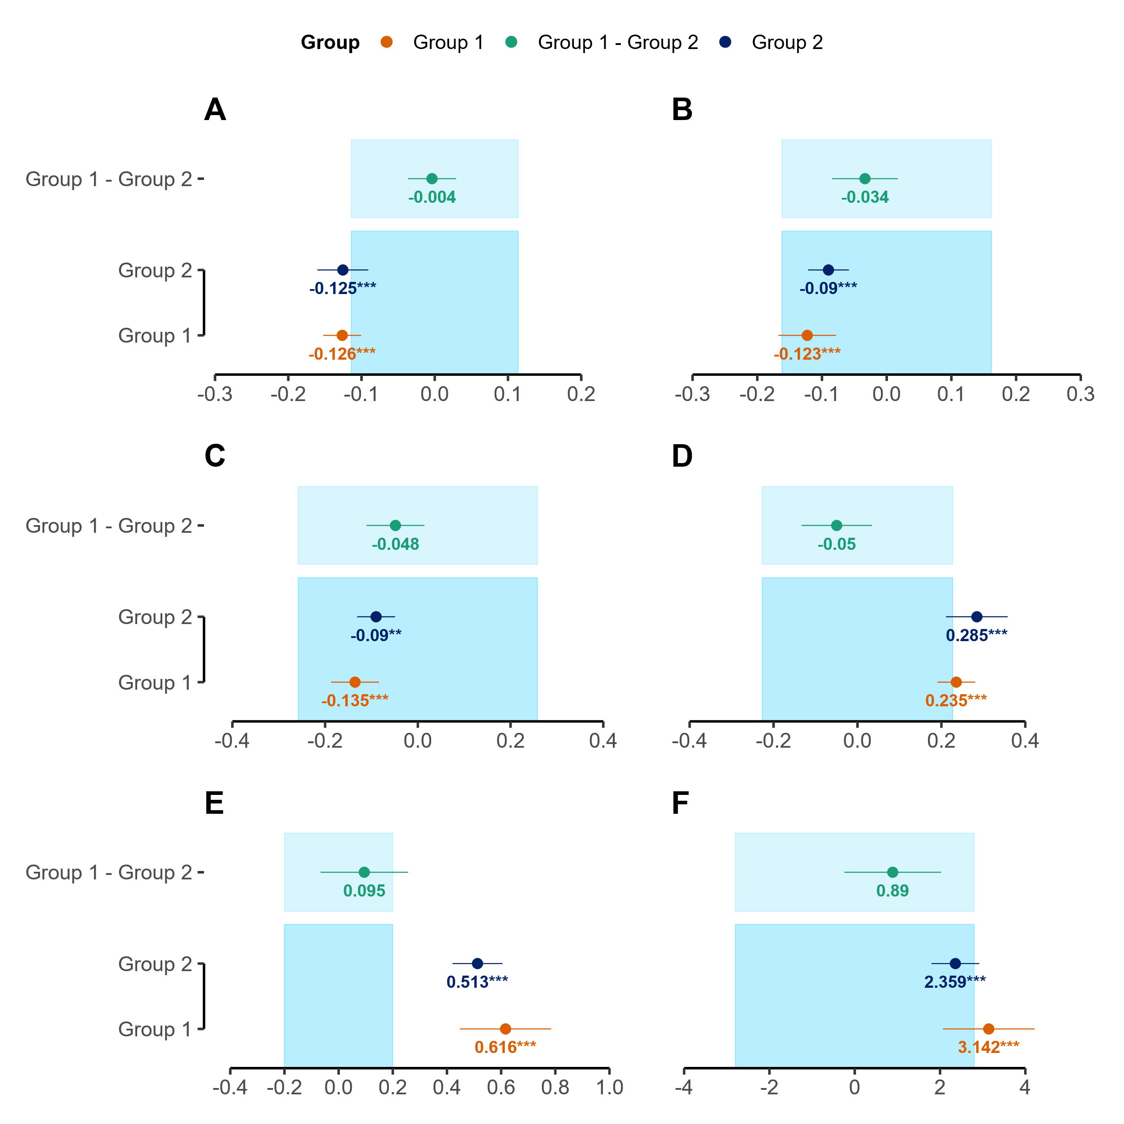
Figure 6. Results for fitness outcomes containing within-group effects (Group 1, Group 2) and between-group effects (Group 1 – Group 2), along with their 90% confidence intervals (* p < 0.05, ** p < 0.01, *** p < 0.001). [A: 10-m sprint time (sec); B: 20-m sprint time (sec); C: 40-m sprint time (sec); D: maximal aerobic speed (m.s⁻¹); E: maximum velocity (m.s⁻¹); F: countermovement jump height (cm)]. The region of practical equivalence for each test is represented by the light blue shaded areas.

Discussion:
Consistent with existing literature, our findings confirm that repeated-sprint training enhances key athletic qualities related to soccer performance in amateur male soccer players (Bortnik et al., 2023; Chmura et al., 2022). The structural variations in our volume- and duration-matched RST protocols led to practically equivalent between-group outcomes for all sprint times (10-m, 20-m, and 40-m) with the matched internal loads likely driving this comparability, as the groups reported practically equivalent dRPE across the study.
Our study’s most compelling findings relate to maximum velocity as both groups achieved statistically significant and practically important within-group improvements, reinforcing the efficacy of repeated-sprint training for developing maximum velocity (Moran et al., 2016; Thurlow, Huynh, et al., 2023). Critically, while the between-group difference was not statistically significant, the confidence intervals were too wide to declare practical equivalence. This suggests the two protocols may indeed have a differential impact on maximum velocity, a finding that warrants further study. These gains likely stem from neuromuscular adaptations, such as improved Type-II fibre recruitment and movement efficiency (Lieberman et al., 2006). In stark contrast, while all within-group improvements in discrete sprint times (10-m, 20-m, 40-m) were statistically significant, none were practically important. This reveals a critical discrepancy: the neuromuscular adaptations that drove significant and practically important gains in maximum velocity did not translate into practically important gains in acceleration performance. This finding should be considered in the context of our conservative analytical approach; previous literature relying on traditional null-hypothesis testing may have overestimated the practical impact of similar short-term interventions on acceleration. We propose that this disconnect between maximum velocity and acceleration can be attributed to several factors. Instantaneous velocity is an inherently more sensitive metric than averaged split times, and it is plausible that a 6-week training duration is simply insufficient to elicit practically important improvements in the complex, multi-faceted skill of acceleration. This may suggest that a longer training duration or a different programming emphasis is required to elicit practically important improvements in the initial phases of a sprint, or that variability in performance over such a short duration is greater than measurable changes.
High aerobic capacity and endurance levels are crucial for soccer players to sustain performance, execute repeated high-intensity actions, and recover effectively throughout a match (Bishop et al., 2011; Girard et al., 2011). In the current study, when comparing the two repeated sprint training protocols, the between-group effect on changes in maximal aerobic speed was found to be statistically non-significant and practically equivalent changes. This indicates that the differing rest structures within the repeated sprint training protocols did not lead to a practically meaningful difference in maximal aerobic speed adaptation between the groups. More notably, while both groups achieved statistically significant within-group improvements in maximal aerobic speed, the magnitude of these gains was not practically important as revealed by equivalence testing. Although previous research has demonstrated that repeated sprint training can induce beneficial physiological adaptations conducive to improved aerobic performance, such as enhanced muscle metabolite clearance, increased oxidative enzyme activity, and shifts in substrate utilisation (Taylor et al., 2015; Thurlow, Huynh, et al., 2023), the 6-week duration of this study was likely insufficient to drive these changes to a point where they translate into a practically meaningful improvement in maximal aerobic speed.
Jumping ability is also an integral component of soccer performance (Faude et al., 2012). While sprint training has been associated with improvements in vertical jump performance (Majid & Fauzi, 2021; Norgeot & Fouré, 2024), our findings regarding countermovement jump height require careful interpretation. The between-group effects on changes in countermovement jump height were statistically non-significant and practically equivalent. Regarding within-group changes, despite both groups achieving statistically significant within-group improvements, the magnitude of these gains was not practically important as revealed by equivalence testing. Neuromuscular adaptations often cited behind countermovement jump improvements, such as improvements in the stretch-shortening cycle, the function of series and parallel elastic components, tendon compliance, and overall movement efficiency (Bradley, 2020; Granacher et al., 2018), did not translate into definitively practically important changes in countermovement jump height within the six-week duration.
Based on our findings, practitioners designing repeated sprint training programs for semi-professional male soccer players should primarily prioritise the total sprint volume and exposure intended for a session or microcycle. For adaptations in short sprint performance (10-meter, 20-meter, 40-meter), maximal aerobic speed, and countermovement jump height, coaches may have considerable flexibility in adjusting within-set and between-set rest periods to suit logistical needs, session objectives, or athlete feedback, provided the total sprint volume and overall recovery are maintained. The choice between protocols similar to those used here is unlikely to yield practically different results for these specific measures. However, practitioners should be mindful that the thresholds defining "practical difference" were based on data derived using varied methodologies. Thus, they require careful contextual interpretation when applied to their specific semi-professional male athletes. Notably, both repeated sprint training protocols employed in this study effectively elicited practically important improvements in maximum velocity over six weeks, making either rest structure a viable option when enhancing this specific quality is a goal. However, practitioners should also manage expectations regarding other adaptations over a similar six-week timeframe, as these specific repeated sprint training protocols did not consistently lead to definitively practically important improvements in all shorter sprint distances, maximal aerobic speed, or countermovement jump height for both groups. Once the core sprint volume is established, further individualisation and integration of repeated sprint training, considering factors like anaerobic speed reserve, inclusion of sport-specific elements such as changes of direction and deceleration components, and player locomotor profiles or positional demands, technical/tactical stimulus combined with small-sided games, remain pertinent (Harper et al., 2024; Ortiz et al., 2024; Sandford et al., 2021). This approach allows repeated sprint training to be effectively incorporated into the weekly microcycle, such as within-session conditioning drills, post-match conditioning or strategic sprint exposure strategically placed relative to match day.
Several limitations should be considered when interpreting our findings. Firstly, the absence of an active control group continuing only regular training makes it challenging to definitively attribute observed adaptations solely to the repeated sprint training interventions, as opposed to the general pre-season environment. Secondly, this study did not incorporate direct physiological measures (e.g., metabolic analyses, muscle oxygenation, detailed biomechanics) and such data could have offered deeper insights into the mechanisms underpinning the maximum velocity improvements and the equivalence in other outcomes. Furthermore, establishing regions of practical equivalence warrants specific attention. Regions of practical equivalence for sprint times and countermovement jump height were derived from elite female soccer players (Datson et al., 2022). While valuable, their direct applicability to define practically relevant changes in the semi-professional male soccer players herein requires cautious interpretation, though comparability is posited and this approach provides a counter to reliance solely on p values. The region of practical equivalence for maximum velocity was adopted from practitioner consensus on measurement error (Kyprianou et al., 2022), and for maximal aerobic speed, it was determined using minimal detectable change from a published coefficient of variation (Bellenger et al., 2015), converted to raw units. This heterogeneity could influence comparative interpretations of practical relevance. Thirdly, while maximal effort was encouraged during repeated sprint training sessions, objective tracking (e.g., Global Positioning System Data) of external training loads during these sprints was not possible due to resource limitations; therefore, precise sprint speeds or distances covered at maximal intensity during training were not objectively verified beyond the ‘coaches eye’. Finally, although overall training exposure was intended to be identical bar intervention variations, and perceived load was equivalent, variations in individual soccer-specific session durations or match minutes might have occurred due to team-specific logistics, representing an uncontrolled variable, albeit likely minimal in impact given the equivalent perceived load.
Building upon this investigation, future research could explore several avenues, including an active control group, which is crucial to isolate repeated sprint training effects. Replication in diverse soccer populations (e.g., female, different competitive levels) would enhance generalisability. A critical area is establishing a robust, population-specific region of practical equivalence for key outcomes in semi-professional male soccer players to refine interpretations of meaningful change. They should incorporate objective external load measures (e.g., Global Positioning System’s data for sprint speeds and accelerations during training) alongside internal load metrics (e.g., heart rate) to better understand training load. Delving into the physiological and biomechanical underpinnings of adaptation to different work-to-rest ratios via direct measures (e.g., muscle biopsy, detailed neuromuscular profiling) is warranted. Expanding repeated sprint training interventions to more ecologically valid modalities (shuttle, curvilinear sprinting) and examining integration with various-sided games are valuable directions. Finally, replicating similar interventions during the competitive in-season period would clarify how repeated sprint training adaptations manifest amidst fixture congestion and how training variables might be periodised to manage the fitness-fatigue paradigm. These future studies, addressing the current limitations, will deepen our understanding of repeated sprint training and its optimal application in soccer.
In summary, the two distinct six-week repeated sprint training protocols, differing in rest intervals but matched for sprint volume and overall recovery, resulted in largely comparable adaptations. Between-group effects for 10-m, 20-m, and 40-m sprint times, maximal aerobic speed, and countermovement jump height were practically equivalent, as was perceived training intensity. The one exception was maximum velocity, with uncertainty regarding practical equivalence in changes between groups, though both achieved practically important within-group improvements. For other measures, within-group changes were either practically equivalent to no change or demonstrated uncertainty around practical importance. The general similarity in outcomes might be attributed to the possibility that distinct physiological stresses imposed by each protocol converged to a similar net training stimulus (Girard et al., 2011; Thurlow, Weakley, et al., 2023). Consequently, overall training volume-load, equated here, may be a more critical determinant than the precise rest interval structure within the ranges explored, aligning with resistance training research (Hamarsland et al., 2022).

References:

Allen, M., Poggiali, D., Whitaker, K., Marshall, T. R., Van Langen, J., & Kievit, R. A. (2021). Raincloud plots: A multi-platform tool for robust data visualization. Wellcome Open Research, 4, 63. https://doi.org/10.12688/wellcomeopenres.15191.2
Altman, D. G., & Bland, J. M. (2005). Treatment allocation by minimisation. BMJ, 330(7495), 843. https://doi.org/10.1136/bmj.330.7495.843
Baguley, T. (2009). Standardized or simple effect size: What should be reported? British Journal of Psychology (London, England: 1953), 100(Pt 3), 603–617. https://doi.org/10.1348/000712608X377117
Bates, D., Mächler, M., Bolker, B., & Walker, S. (2015). Fitting Linear Mixed-Effects Models Using lme4. Journal of Statistical Software, 67(1), 1–48. https://doi.org/10.18637/jss.v067.i01
Bellenger, C. R., Fuller, J. T., Nelson, M. J., Hartland, M., Buckley, J. D., & Debenedictis, T. A. (2015). Predicting maximal aerobic speed through set distance time-trials. Eur J Appl Physiol, 115(12), 2593–2598. https://doi.org/10.1007/s00421-015-3233-6
Bishop, D., Girard, O., & Mendez-Villanueva, A. (2011). Repeated-sprint ability—Part II: recommendations for training. Sports Med, 41(9), 741–756. https://doi.org/10.2165/11590560-000000000-00000
Borg, E., Borg, G., Larsson, K., Letzter, M., & Sundblad, B.-M. (2010). An index for breathlessness and leg fatigue. Scandinavian Journal of Medicine & Science in Sports, 20(4), 644–650. https://doi.org/10.1111/j.1600-0838.2009.00985.x
Bortnik, L., Bruce-Low, S., Burger, J., Alexander, J., Harper, D., Morgans, R., Carling, C., McDaid, K., & Rhodes, D. (2023). Physical match demands across different playing positions during transitional play and high-pressure activities in elite soccer. Biology of Sport, 41, 73–82. https://doi.org/10.5114/biolsport.2024.131815
Bradley, M. (2020). Plyometric training and its effects on the neuromuscular system. https://rdw.rowan.edu/etd/2774/
Burnham, K. P., Anderson, D. R., & Huyvaert, K. P. (2011). AIC model selection and multimodel inference in behavioral ecology: Some background, observations, and comparisons. Behavioral Ecology and Sociobiology, 65(1), 23–35. https://doi.org/10.1007/s00265-010-1029-6
Castillo-Rodríguez, A., Cano-Cáceres, F. J., Figueiredo, A., & Fernández-García, J. C. (2020). Train Like You Compete? Physical and Physiological Responses on Semi-Professional Soccer Players. International Journal of Environmental Research and Public Health, 17(3), 756. https://doi.org/10.3390/ijerph17030756
Chmura, P., Oliva-Lozano, J. M., Muyor, J. M., Andrzejewski, M., Chmura, J., Czarniecki, S., Kowalczuk, E., Rokita, A., & Konefał, M. (2022). Physical Performance Indicators and Team Success in the German Soccer League. J Hum Kinet, 83, 257–265. https://doi.org/10.2478/hukin-2022-0099
Collings, T. J., Lima, Y. L., Dutaillis, B., & Bourne, M. N. (2024). Concurrent validity and test–retest reliability of VALD ForceDecks’ strength, balance, and movement assessment tests. Journal of Science and Medicine in Sport. https://doi.org/10.1016/j.jsams.2024.04.014
Cook, B. G., Cook, L., & Therrien, W. J. (2018). Group‐Difference Effect Sizes: Gauging the Practical Importance of Findings from Group‐Experimental Research. Learning Disabilities Research & Practice, 33(2), 56–63. https://doi.org/10.1111/ldrp.12167
Datson, N., Lolli, L., Drust, B., Atkinson, G., Weston, M., & Gregson, W. (2022). Inter-methodological quantification of the target change for performance test outcomes relevant to elite female soccer players. Science and Medicine in Football, 6(2), 248–261. https://doi.org/10.1080/24733938.2021.1942538
De Vet, H. C. W., & Terwee, C. B. (2010). The minimal detectable change should not replace the minimal important difference. Journal of Clinical Epidemiology, 63(7), 804–805. https://doi.org/10.1016/j.jclinepi.2009.12.015
Faude, O., Koch, T., & Meyer, T. (2012). Straight sprinting is the most frequent action in goal situations in professional football. J Sports Sci, 30(7), 625–631. https://doi.org/10.1080/02640414.2012.665940
Freitas, T. T., Pereira, L. A., Reis, V. P., Fernandes, V., Alcaraz, P. E., Azevedo, P. H. S. M., & Loturco, I. (2021). Effects of a Congested Fixture Period on Speed and Power Performance of Elite Young Soccer Players. International Journal of Sports Physiology and Performance, 16(8), 1120–1126. https://doi.org/10.1123/ijspp.2020-0280
Ganju, J., & Rom, D. (2017). Non-inferiority versus superiority drug claims: The (not so) subtle distinction. Trials, 18(1), 278. https://doi.org/10.1186/s13063-017-2024-2
Girard, O., Mendez-Villanueva, A., & Bishop, D. (2011). Repeated-sprint ability—Part I: factors contributing to fatigue. Sports Med, 41(8), 673–694. https://doi.org/10.2165/11590550-000000000-00000
Granacher, U., Puta, C., Gabriel, H. H. W., Behm, D. G., & Arampatzis, A. (2018). Editorial: Neuromuscular Training and Adaptations in Youth Athletes. Frontiers in Physiology, 9, 1264. https://doi.org/10.3389/fphys.2018.01264
Haff, G. G., & Triplett, N. T. (2015). Essentials of Strength Training and Conditioning 4th Edition. Human Kinetics.
Hamarsland, H., Moen, H., Skaar, O. J., Jorang, P. W., Rødahl, H. S., & Rønnestad, B. R. (2022). Equal-Volume Strength Training With Different Training Frequencies Induces Similar Muscle Hypertrophy and Strength Improvement in Trained Participants. Frontiers in Physiology, 12. https://doi.org/10.3389/fphys.2021.789403
Harper, D., Cervantes, C., Van Dyke, M., Evans, M., McBurnie, A., Dos’ Santos, T., Eriksrud, O., Cohen, D., Rhodes, D., Carling, C., & Kiely, J. (2024). The Braking Performance Framework: Practical Recommendations and Guidelines to Enhance Horizontal Deceleration Ability in Multi-Directional Sports. International Journal of Strength and Conditioning, 4(1). https://doi.org/10.47206/ijsc.v4i1.351
Hill-Haas, S., Bishop, D., Dawson, B., Goodman, C., & Edge, J. (2007). Effects of rest interval during high-repetition resistance training on strength, aerobic fitness, and repeated-sprint ability. J Sports Sci, 25(6), 619–628. https://doi.org/10.1080/02640410600874849
Iaia, F. M., Fiorenza, M., Larghi, L., Alberti, G., Millet, G. P., & Girard, O. (2017). Short- or long-rest intervals during repeated-sprint training in soccer? PLoS One, 12(2), e0171462. https://doi.org/10.1371/journal.pone.0171462
Jukic, I., Ramos, A. G., Helms, E. R., McGuigan, M. R., & Tufano, J. J. (2020). Acute Effects of Cluster and Rest Redistribution Set Structures on Mechanical, Metabolic, and Perceptual Fatigue During and After Resistance Training: A Systematic Review and Meta-analysis. Sports Med, 50(12), 2209–2236. https://doi.org/10.1007/s40279-020-01344-2
Kassambara, A. (2023). ggpubr: ‘ggplot2’ Based Publication Ready Plots [Computer software]. R package version 0.6.0.
Kyprianou, E., Di Salvo, V., Lolli, L., Al Haddad, H., Villanueva, A. M., Gregson, W., & Weston, M. (2022). To Measure Peak Velocity in Soccer, Let the Players Sprint. Journal of Strength and Conditioning Research, 36(1), 273–276. https://doi.org/10.1519/JSC.0000000000003406
Lakens, D. (2022). Sample Size Justification. Collabra: Psychology, 8(1), 33267. https://doi.org/10.1525/collabra.33267
Lakens, D., Scheel, A. M., & Isager, P. M. (2018). Equivalence Testing for Psychological Research: A Tutorial. Advances in Methods and Practices in Psychological Science, 1(2), 259–269. https://doi.org/10.1177/2515245918770963
Laursen, P., & Buchheit, M. (2019). Science and Application of High-Intensity Interval Training: Solutions to the Programming Puzzle. Human Kinetics.
Lieberman, D. E., Raichlen, D. A., Pontzer, H., Bramble, D. M., & Cutright-Smith, E. (2006). The human gluteus maximus and its role in running. Journal of Experimental Biology, 209(11), 2143–2155. https://doi.org/10.1242/jeb.02255
Lüdecke, D. (2024). sjPlot: Data Visualization for Statistics in Social Science.
Lüdecke, D., Ben-Shachar, M. S., Patil, I., Wiernik, B. M., Bacher, E., Thériault, R., & Makowski, D. (2022). easystats: Framework for Easy Statistical Modeling, Visualization, and Reporting. CRAN.
Majid, N. C., & Fauzi, F. (2021). The Effect of Sprint Training on Vertical Jump Height of Female Youth Volleyball Players. International Journal of Human Movement and Sports Sciences, 9(2), 334–339. https://doi.org/10.13189/saj.2021.090222
Marcote-Pequeño, R., García-Ramos, A., Cuadrado-Peñafiel, V., González-Hernández, J. M., Gómez, M., & Jiménez-Reyes, P. (2019). Association Between the Force-Velocity Profile and Performance Variables Obtained in Jumping and Sprinting in Elite Female Soccer Players. Int J Sports Physiol Perform, 14(2), 209–215. https://doi.org/10.1123/ijspp.2018-0233
McKay, A. K. A., Stellingwerff, T., Smith, E. S., Martin, D. T., Mujika, I., Goosey-Tolfrey, V. L., Sheppard, J., & Burke, L. M. (2022). Defining Training and Performance Caliber: A Participant Classification Framework. International Journal of Sports Physiology and Performance, 17(2), 317–331. https://doi.org/10.1123/ijspp.2021-0451
McLaren, S. J., Graham, M., Spears, I. R., & Weston, M. (2016). The Sensitivity of Differential Ratings of Perceived Exertion as Measures of Internal Load. Int J Sports Physiol Perform, 11(3), 404–406. https://doi.org/10.1123/ijspp.2015-0223
McLaren, S. J., Smith, A., Spears, I. R., & Weston, M. (2017). A detailed quantification of differential ratings of perceived exertion during team-sport training. J Sci Med Sport, 20(3), 290–295. https://doi.org/10.1016/j.jsams.2016.06.011
Moran, J., Sandercock, G., Rumpf, M., & Parry, D. (2016). Variation in Responses to Sprint Training in Male Youth Athletes: A Meta-analysis. International Journal of Sports Medicine, 38(01), 1–11. https://doi.org/10.1055/s-0042-111439
Negra, Y., Sammoud, S., Ramirez-Campillo, R., Bouguezzi, R., Moran, J., & Chaabene, H. (2023). The effects of repeated sprint training with versus without change of direction on measures of physical fitness in youth male soccer players. J Sports Med Phys Fitness, 63(1), 8–15. https://doi.org/10.23736/s0022-4707.22.13521-8
Norgeot, F., & Fouré, A. (2024). Effects of vertical and horizontal plyometric training on jump performances and sprint force–velocity profile in young elite soccer players. European Journal of Applied Physiology, 124(9), 2591–2601. https://doi.org/10.1007/s00421-024-05477-4
Ortigosa-Melero, A., Onetti, W., Figueiredo, A., & Castillo-Rodríguez, A. (2022). Effect of the contextual factors in competition on the performance of semi- professional soccer. Journal of Physical Education and Sport, 22, 2793–2799. https://doi.org/10.7752/jpes.2022.11354
Ortiz, J. G., De Lucas, R. D., Teixeira, A. S., Mohr, P. A., & Guglielmo, L. G. A. (2024). Match-Play Running Performance in Professional Male Soccer Players: The Role of Anaerobic Speed Reserve. Research Quarterly for Exercise and Sport, 95(3), 680–687. https://doi.org/10.1080/02701367.2023.2294102
Pustejovsky, J. (2024). clubSandwich: Cluster-Robust (Sandwich) Variance Estimators with Small-Sample Corrections. http://jepusto.github.io/clubSandwich/
Pustejovsky, J. E., & Tipton, E. (2018). Small-Sample Methods for Cluster-Robust Variance Estimation and Hypothesis Testing in Fixed Effects Models. Journal of Business & Economic Statistics, 36(4), 672–683. https://doi.org/10.1080/07350015.2016.1247004
Roe, G., Darrall-Jones, J., Black, C., Shaw, W., Till, K., & Jones, B. (2017). Validity of 10-HZ GPS and Timing Gates for Assessing Maximum Velocity in Professional Rugby Union Players. Int J Sports Physiol Perform, 12(6), 836–839. https://doi.org/10.1123/ijspp.2016-0256
Sandford, G. N., Laursen, P. B., & Buchheit, M. (2021). Anaerobic Speed/Power Reserve and Sport Performance: Scientific Basis, Current Applications and Future Directions. Sports Medicine, 51(10), 2017–2028. https://doi.org/10.1007/s40279-021-01523-9
Saraslanidis, P., Petridou, A., Bogdanis, G. C., Galanis, N., Tsalis, G., Kellis, S., & Mougios, V. (2011). Muscle metabolism and performance improvement after two training programmes of sprint running differing in rest interval duration. J Sports Sci, 29(11), 1167–1174. https://doi.org/10.1080/02640414.2011.583672
Senn, S. (2006). Change from baseline and analysis of covariance revisited. Statistics in Medicine, 25(24), 4334–4344. https://doi.org/10.1002/sim.2682
Shushan, T., Lovell, R., McLaren, S. J., Buchheit, M., Dello Iacono, A., Arguedas-Soley, A., & Norris, D. (2024). Assessing criterion and longitudinal validity of submaximal heart rate indices as measures of cardiorespiratory fitness: A preliminary study in football. J Sci Med Sport. https://doi.org/10.1016/j.jsams.2024.04.006
Silva, H., Nakamura, F. Y., Castellano, J., & Marcelino, R. (2023). Training Load Within a Soccer Microcycle Week—A Systematic Review. Strength & Conditioning Journal, 45(5), 568–577. https://doi.org/10.1519/ssc.0000000000000765
Taylor, J., Macpherson, T., Spears, I., & Weston, M. (2015). The effects of repeated-sprint training on field-based fitness measures: A meta-analysis of controlled and non-controlled trials. Sports Med, 45(6), 881–891. https://doi.org/10.1007/s40279-015-0324-9
Thurlow, F., Huynh, M., Townshend, A., McLaren, S. J., James, L. P., Taylor, J. M., Weston, M., & Weakley, J. (2023). The Effects of Repeated-Sprint Training on Physical Fitness and Physiological Adaptation in Athletes: A Systematic Review and Meta-Analysis. Sports Med. https://doi.org/10.1007/s40279-023-01959-1
Thurlow, F., Weakley, J., Townshend, A. D., Timmins, R. G., Morrison, M., & McLaren, S. J. (2023). The Acute Demands of Repeated-Sprint Training on Physiological, Neuromuscular, Perceptual and Performance Outcomes in Team Sport Athletes: A Systematic Review and Meta-analysis. Sports Medicine, 53(8), 1609–1640. https://doi.org/10.1007/s40279-023-01853-w
Tierney, N. (2017). visdat: Visualising Whole Data Frames. The Journal of Open Source Software, 2(16), 355. https://doi.org/10.21105/joss.00355
Turner, A. N., & Stewart, P. F. (2014). Strength and Conditioning for Soccer Players. Strength & Conditioning Journal, 36(4), 1–13. https://doi.org/10.1519/ssc.0000000000000054
Weakley, J., McCosker, C., Chalkley, D., Johnston, R., Munteanu, G., & Morrison, M. (2023). Comparison of Sprint Timing Methods on Performance, and Displacement and Velocity at Timing Initiation. J Strength Cond Res, 37(1), 234–238. https://doi.org/10.1519/jsc.0000000000004223
Weakley, J., Pérez Castilla, A., García Ramos, A., Banyard, H., Thurlow, F., Edwards, T., Morrison, M., McMahon, E., & Owen, C. (2023). Effect of Traditional, Rest Redistribution, and Velocity-Based Prescription on Repeated Sprint Training Performance and Responses in Semiprofessional Athletes. J Strength Cond Res, 37(8), 1566–1572. https://doi.org/10.1519/jsc.0000000000004438
Will G Hopkins. (2010). Assigning Subjects to Groups in a Controlled Trial. Sportscience, Volume 14(2010), 7–12.
Wright, M. D., Songane, F., Emmonds, S., Chesterton, P., Weston, M., & Mclaren, S. J. (2020). Differential Ratings of Perceived Match and Training Exertion in Girls’ Soccer. International Journal of Sports Physiology and Performance, 15(9), 1315–1323. https://doi.org/10.1123/ijspp.2019-0595

Appendix:

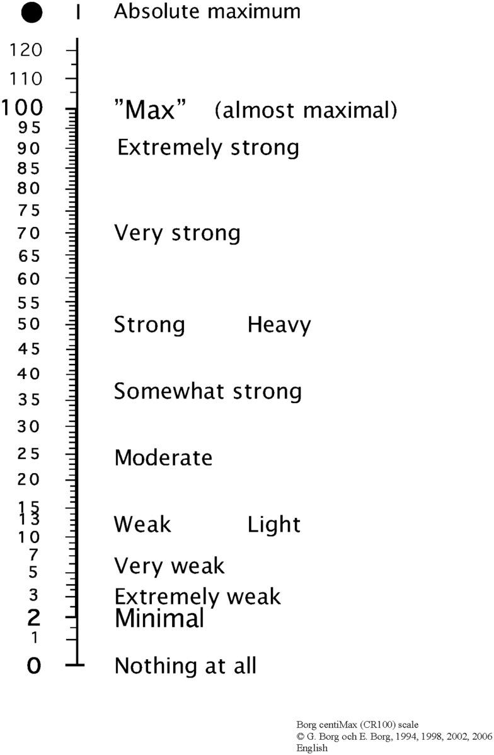

Figure 6: Borg CR100 Scale

Data Availability Statement:

The data that support the findings of this study are openly available in at [https://1drv.ms/f/c/f21c6b0ed166bf49/EvtaQYZEUN9PoG_F4liD_zoBL3d3o-8dopieZcOel-VFgQ?e=1k0QyG].

